ULTRASONIC TESTING REPORT
Company/Client |  | NCOC N. V. |  | Project |  | ESKENE WEST |  | Location |  | Oil Tr-3
Line No/Tag No: |  | A1-2103-RO-016-18-A11-HC |  | Material |  | A333 Gr.6 SMLS |  | Día × Nominal Thickness |  | 18” 9.52
Procedure No: |  | QP-11-UTT-Q01 Rev 03  GOST 28702-90 |  | Calibration Block |  | Step wedge |  | Probe  S/N |  | D790  1196661
 |  |  |  | Calibration block Range |  | 2.50-12.50 mm |  | Angle |  | 0º
Manufacturing Code |  | ASME B31.3 |  | Calibration Temp |  | -1ºC |  | Frequency |  | 5 MHz
 |  |  |  | Object Temp |  | +139ºC |  | Size |  | 5.1 mm
Acceptance Standard: |  | Acc. to the client specif. |  | Correction factors |  | Calculated by 38DL in high temperature mode automatically |  | Crystal |  | Dual
Surface condition |  | Coated |  | Couplant |  | High temperature UT Gel ʺHiTempco" |  | Accuracy |  | ± 0,1 mm
S. No | Equipment/  Material Name |  | Manufacturer |  | Serial No |  | Calibration certificate No |  | Calibration Expiry date
 | DL-38 |  | OLYMPUS |  | 171421601 |  | BK-01-0674 |  | 20-03-2020
 | Step calibration block 2214M |  | OLYMPUS |  | 026519 |  | - |  | -
Job description:

- UT spot check performed on (A1-2103-RO-016-18-A11-HC& KE01-A1-210-PZ-P-DI-2860-001)
- Inspection performed on East, West, South, North, Top, Bottom and Extrados from external.
- Echo to echo UT technique was used.
Notes:
N/A – not applicable.

Inspection drawing
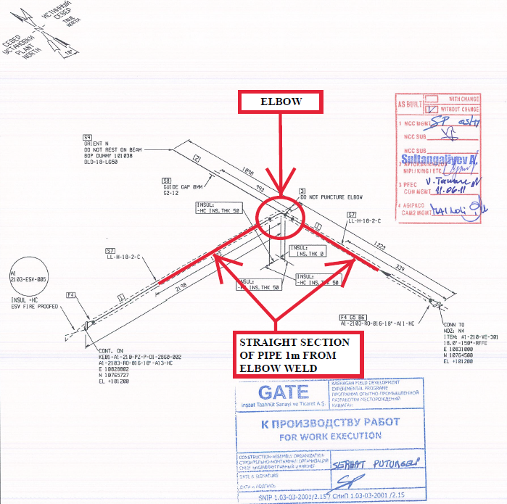
Loc 1
Loc 2
Loc 3

A1-2103-RO-016-18-A11-HC& KE01-A1-210-PZ-P-DI-2860-001

Inspection results
S/NO | Location | Item description | Spot check  Location | DIA(Ø), inch | Nominal thickness, mm | Top  mm | Bottom  mm | East  mm | West  mm | South  mm | North  mm | Extrados mm | Intrados  mm
1 | Loc 1 | Pipe | 1 | 18” | 9.52 | 9.44 | 9.41 | - | - | 9.38 | 9.24 | -
1 | Loc 1 | Pipe | 2 | 18” | 9.52 | 9.44 | 9.36 | - | - | 9.39 | 9.86
2 | Loc 2 | Elbow | 1 | 18” | 9.52 | 9.18 | 8.98 | 9.12 | 9.47 | - | - | -
2 | Loc 2 | Elbow | 2 | 18” | 9.52 | 8.89 | 8.94 | 8.84 | n/a | - | - | - | -
2 | Loc 2 | Elbow | 3 | 18” | 9.52 | 8.61 | 9.78 | - | - | - | - | - | 9.12
2 | Loc 2 | Elbow | 4 | 18” | 9.52 | 9.16 | 8.97 | - | - | 8.80 | - | 9.51 | -
2 | Loc 2 | Elbow | 5 | 18” | 9.52 | 9.03 | 8.81 | - | - | 9.45 | 8.86 | - | -
3 | Loc 3 | Pipe | 1 | 18” | 9.52 | 10.28 | 9.47 | 9.69 | 10.13 | - | - | - | -

Examined by  UT L II cert. No. 734  exp. date 18.02.2022 | Name: Farkhatov Raimbek | Signature: ............................ | Date: 24 Feb 2020
Approved by:  UT Level II cer. No 1A 253/15  exp date: 31.05.2020 | Name: Shakunou Andrei | Signature: .......................... | Date: 24 Feb 2020
Client Representative: | Name: …………………………… | Signature: ............................ | Date: ………………

